PROGRAMMING FUNDAMENTALS=LAB TASKS N0 05

LAB TASK#1
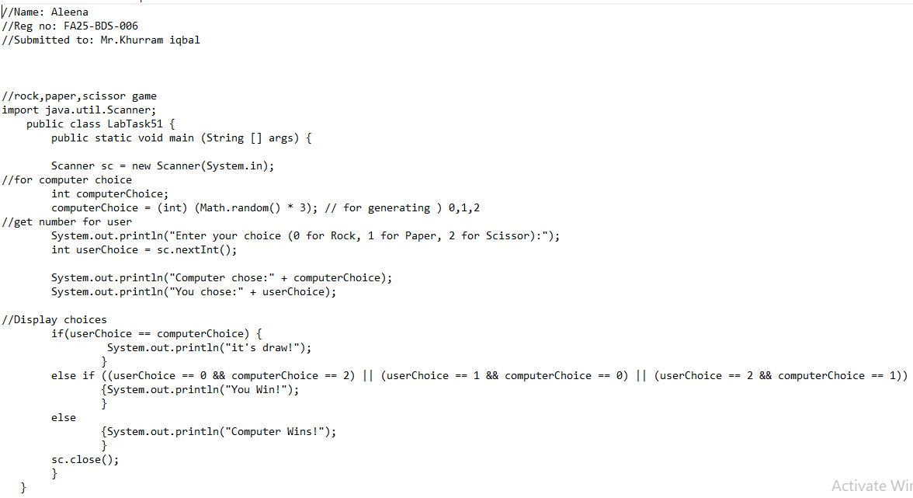
OUT PUT:1
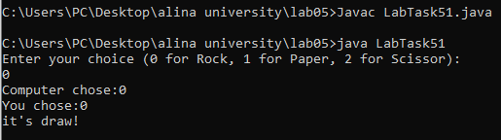

LAB TASK#2
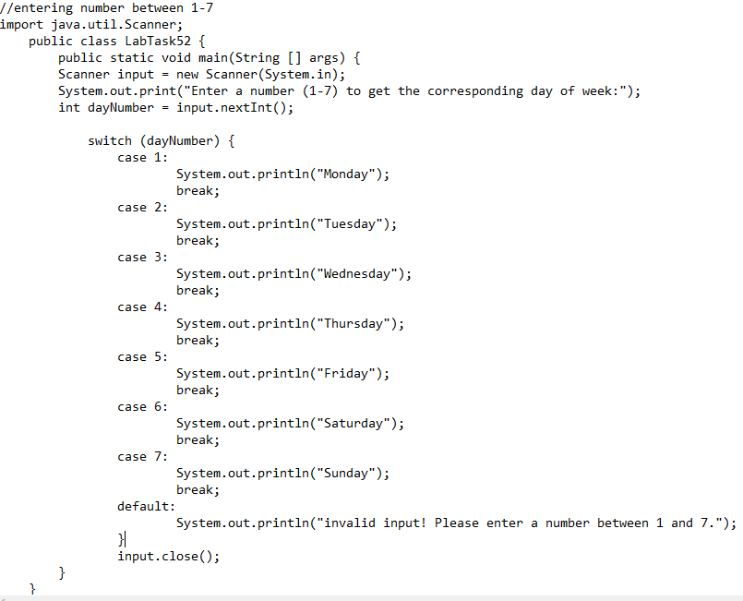
OUT PUT:2
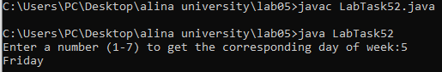

LAB TASK#3
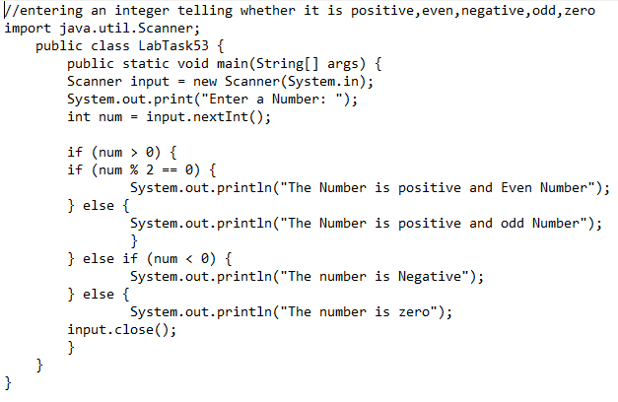
OUT PUT:3
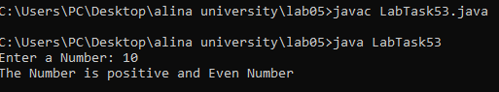
LAB TASK#4
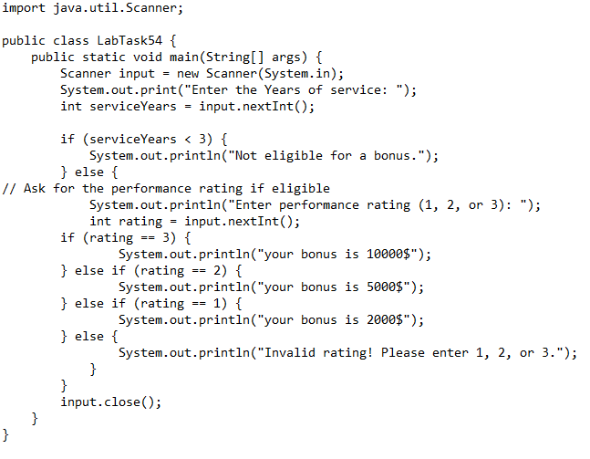
OUT PUT:4
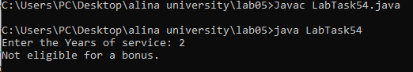

PSEUDO CODE OF LAB TASK#5
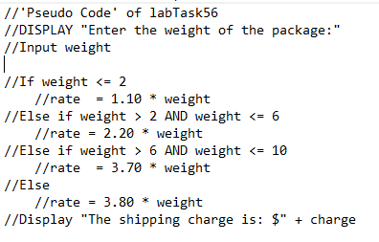
LAB TASK#5
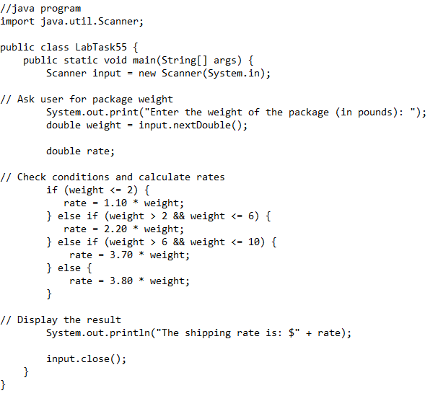
OUT PUT:5
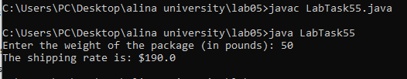

PSEUDO CODE OF LAB TASK#6
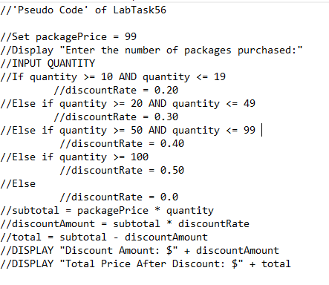
LAB TASK#6
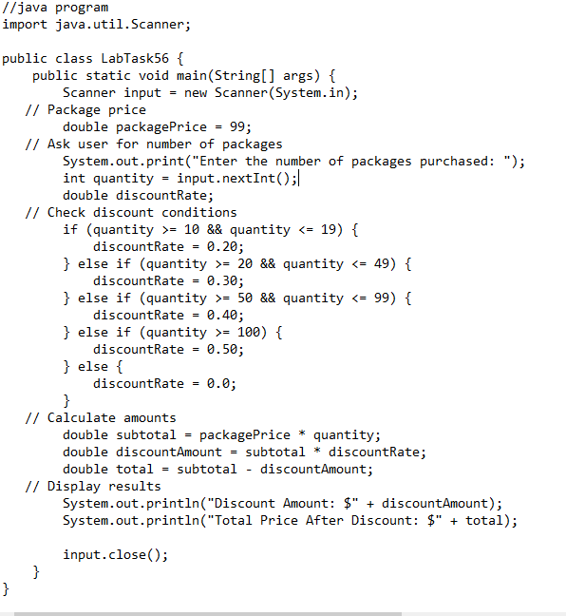
OUT PUT:6
